1. Construct a DFA that accepts a language L over input alphabets    
   ∑ = {a, b} such that L is the set of all strings starting with ‘aa’ or ‘bb’.
2. Construct a DFA that accepts a language L over input alphabets ∑ = {a, b} such that L is the set of all strings starting with ‘aba’.

<https://www.gatevidyalay.com/construction-of-dfa-examples-dfa-solved-examples/>

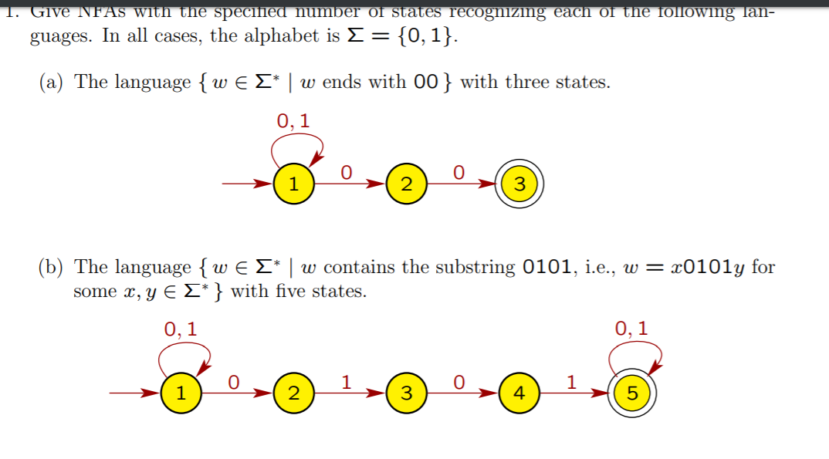

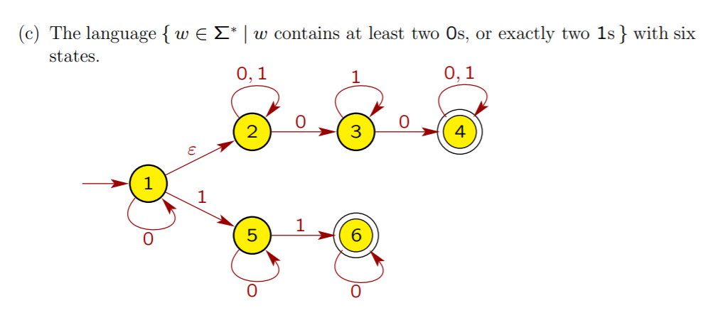

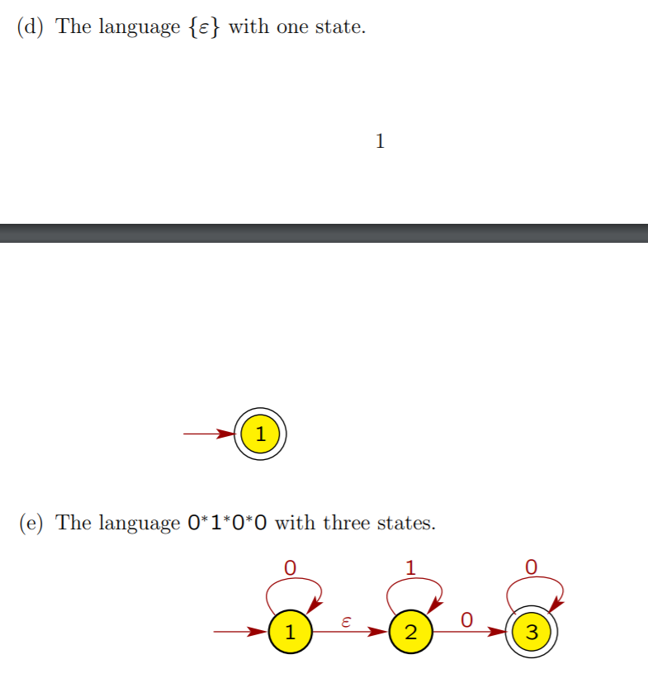

Draw NFA (4 states)  
L = { (a^n | n>=0) Union (b^na | n>=0)}